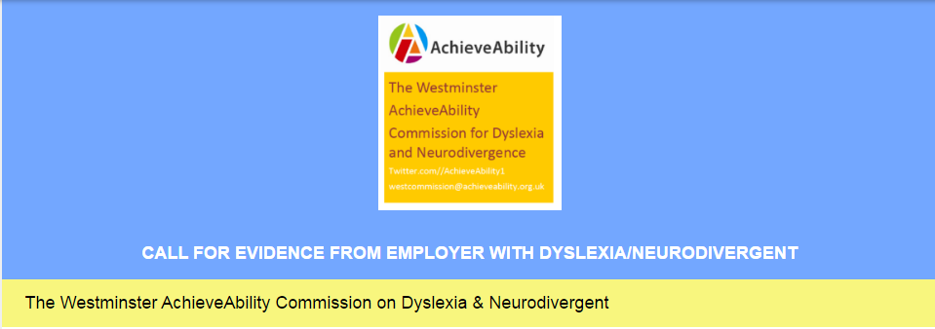
The Westminster AchieveAbility Commission for Dyslexia & Neurodivergence:
Opening the doors to employment
CALL FOR EVIDENCE FROM EMPLOYEE WITH DYSLEXIA/NEURODIVERGENT
We want to hear your experiences
The charity Westminster AchieveAbility Commission (WAC) on Dyslexia & Neurodivergence recognise that all selection procedures are intended to identify the best person for the job. However, we have reason to suspect that dyslexic and other neurodivergent applicants may be prevented from applying, or being successful in their application, even when they could be the best person for the job.

This questionnaire is intended to discover the current state of play, to uncover good practice and make recommendations. All responses will remain confidential and we would like to thank you for your help. The commission is investigating the barriers to employment and identifying recruitment processes that advantage/disadvantage neurodivergent people (with autism, ADHD, dyslexia, dyspraxia, dyscalculia, asperger’s). The aim is to find out how recruitment and probation processes might be improved and highlight good practice in these areas.
Our final report will make recommendations to the government on removing barriers to employment by identifying recruitment processes that disadvantage neurodivergent people.The Commission will feed into the government goal of ‘Halving the Disability Employment Gap’ by 2020. Dyslexic people, and those who are Neurodivergent, represent the highest percentage of adults who are disabled (British Dyslexia Association) this Commission is therefore vital in order to represent the issues for this community, as well as revealing their intellect, value and strengths within the workplace.
PLEASE could we ask you to help fill in this survey for the Westminster AchieveAbility Commission.
You must be an employer or filling this survey on behalf of an employer within the United Kingdom to help with this survey. The closing date is the 30th April 2017.
If you would like to know more information about the commission please see the following website
http://www.achieveability.org.uk/main/policy/new-commission

The Commission is made up of the following members:
Barry Sheerman MP ( Chair of the Westminster AchieveAbility Commission)
Lord Addington Adviser (dyslexic and neurodivergent advocate),
Dr Ross Cooper Design of surveys, report writing (AchieveAbility- dyslexic and neurodivergent advocate)
Melanie Jameson Publicity, dissemination, networks and adviser (Chair of Dyslexia Adult Network)
Craig Kennady Technology and surveys (dyslexic and neurodivergent advocate)
Emily Christou Adviser (National Strategy coordinator for the Autism report)
Richard Todd, Quality assurance (Dyspraxia Foundation)
Pierre Marsh Expertise on diversity (AchieveAbility- dyslexic and neurodivergent advocate)
Katherine Hewlett, Continuity, report writing (AchieveAbility-dyslexic and neurodivergent advocate)

Intended outcomes of the Commission
To close the dyslexic and neurodivergent employment gap
To demonstrate barriers to recruitment
To consider how dyslexic and neurodivergent people deal with disclosure
To profile a set of good practice case studies
To outline a series of recommendations on policy, law and practice
To feed into the government’s stated aim of Halving the Disability Employment Gap

We are committed to providing this survey in the most accessible format as possible. If you find undertaking this survey particularly difficult and would prefer speak to someone please leave your details on our commission phone line or send a text and we will get back to you asap.

Call or Text 0737 565 5699
If you choose to allow us, we will share your responses and use these in our report however all names will be changed to ensure confidentiality. Your answers will not be used for any other purpose

* 1. Can we use your answers in our report? All names will be changed to ensure confidentiality.

YES | NO

If you are filling this survey in as an advocate for someone please answer, where possible, how they would answer for themselves.

* 2. About your organisation?

What is your name?

Your organisation name?

Your position within the organisation?

* 3. Do you have any connection to Dyslexia/Neurodivergence
(This could be yourself, Organisation/Work, Family Member or Friend)
*Please select as many options from the list below as best represent your neurodivergent experience?

No connection to Dyslexia/Neurodivergence | Dyscalculic
Dyslexic | Dysgraphic
Dyspraxic | Tourettes
Autistic Person (including Asperger's) | OCD
ADHD | Other Neurodivergent connection
Would you be happy sharing your connection to Dyslexic/Neurodivergence
(This could be your Yourself, Organisation/Work, Family Member or Friend)

* 4. To which sector does your organisation belong?

(Retail, Government, Public Sector Voluntary Sector)

* 5. In which UK Region do you employ your staff?
(Please tick all that apply)

Nationwide | Scotland
East | South East
East Midlands | South West
London | Wales
North East | West Midlands
North West | Yorkshire And The Humber
Northern Ireland

* 6. Is your workplace a:

Small enterprise? | Large enterprise?
Medium enterprise? | Public sector
Other (please specify)

* 7. How many staff do you employ?

* 8. Do you currently have dyslexic or neurodivergent employees?

YES | NO
Do you mind us asking how many you employ? (please specify)

* 9. Have you undertaken an equality impact assessment of your selection process?

YES | NO
If Yes What did this change in your practice?
(please specify)

* 10. Do you feel sufficiently aware of dyslexic strengths and difficulties to make selections for job roles and promotion?

YES | Sometimes | NO

Reasonable Adjustments

* 11. Do you understand how to make reasonable adjustments for dyslexic and neurodivergent staff?

YES | Sometimes | NO

* 12. Do you make reasonable adjustments for dyslexic and neurodivergent candidates?

YES If you answer move to question 13 | NO If you answer move to question 14

* 13. Based on your last answer
Can you describe what these reasonable adjustments are?

Applying for employment

* 14. When placing adverts, do you make them accessible to dyslexic and neurodivergent applicants?

YES | NO
Can you describe how this is done? (please specify)

* 15. When sending information to applicants, is it in bullet points rather than continuous text?

No | Sometimes | Usually | Always

* 16. During the application process, how to you ask for information from candidates?
(Please tick all that apply)

Application Forms Paper Format | Application Forms Online | Covering Letter
CV required | Presentation required
Other

* 17. Do you ask for a CV to be supplied?

No | Sometimes | Usually | Always

* 18. Do you require online forms to be filled in during the recruitment process?

Yes Always | Yes Usually | Yes sometimes | No

* 19. How do you ensure that on line forms accessible to dyslexic and neurodivergent applicants?
(Please tick all that apply)

Do they include spellcheckers? | Do they allow redrafting? | Do you avoid white backgrounds?
Do they include breadcrumb trails so that applicants can track? | Do they require passwords?

* 20. Do you require online forms to be filled in during the recruitment process?

Yes Always | Yes Usually | Yes sometimes | No
Other (please specify)

* 21. Have you got policies in place to ensure accessibility to selection processes for dyslexic and neurodivergent applicants?

YES | NO

* 22. Based on your last answer

If you said YES Can you share these policies? or a web link?

* 23. Do you support and encourage disclosure during selection processes?

YES | NO
How is this done while reassuring the applicant that they will not be disadvantaged? (please specify)

* 24. Do you have a policy on multi-questions at interviews (asking several questions at once)?

YES | NO

* 25 Do you require online forms to be filled in during the interview process?

Yes Always | Yes Usually | Yes sometimes | No

* 26. How do you ensure that these forms are accessible to dyslexic and neurodivergent applicants?
(Please tick all that apply)

Do they include spellcheckers? | Do they allow redrafting? | Do you avoid white backgrounds?
Do they include breadcrumb trails so that applicants can track? | Do they require passwords?

* 27 Do you require paper forms to be filled in during the interview process?

Yes Always | Yes Usually | Yes sometimes | No

* 28. Do you use psychometric tests during the selection or promotion process?

YES | NO

29. Based on your last answer

Have these been independently analysed to ensure no bias against dyslexic and neurodivergent applicants?

YES | NO
What did this change about your practice? (please specify)

* 30. Do you offer a neutral support person for interviews?

YES | NO

* 31. How do you contact applicants?(Please tick all that apply)

By letter? | By Email?
By text ? | By Telephone?
Other (please specify)

Support from The Department for Work & Pensions

* 32. Have you ever had support from The Department for Work & Pensions (including Job centre Plus)

YES | NO

* 33. Have you ever used any of the following Government programme (Please tick all that apply)

Access to Work | Work Choice | Specialist Employability Support

These symbols are used by Employers 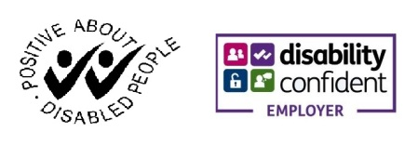

* 34. 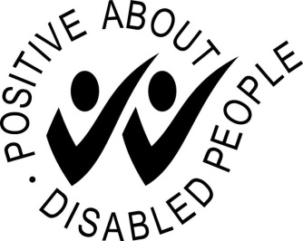 |  | * 35. 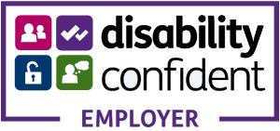
Did your employer use this symbol? |  | Did your employer use this symbol?
YES | NO | YES | NO
Do you know what it means? |  | Do you know what it means?
YES | NO | YES | NO

* 36. Do you offer extra support during a probationary period?

YES | NO
Can you tell us what support you offer? (please specify)

* 37. Do you feel that dyslexic and neurodivergent staff present more strengths than challenges?

YES | NO

* 38. We are looking for examples of good practice, can you share some with us?

The Westminster AchieveAbility Commission on dyslexia and neurodivergence would like to thank you for completing this survey. Please do share with employers. If you would like to be kept up to date and would like to receive an online version of our final report, please fill in your details in section 40 below. Your details will not be shared with others.

* 39. How did you hear about this survey?

40. Contact Information

Name | Postal Code
Company | Country
Address | Email Address
City/Town | Phone Number

41. We are committed to providing updates in formats that are accessible to you. Please help us by letting us know if you would like to receive information in an alternate format other than email and we will try our best to support you.

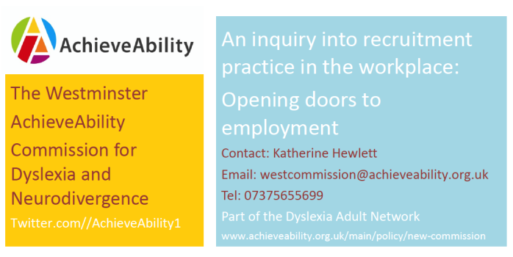
The Commission aims to bring about positive change by bringing people together to publish and promote this evidence. The report will outline a series of recommendations and is to be launched during Dyslexia Awareness Week, October 2017.

This work will add to evidence and provide other campaigning groups a platform from which to push this agenda further, aligned with the government’s stated aim of ‘Halving the Disability Employment Gap’. With a Green Paper on employment on the way, there could be no better time to highlight the employment needs of this large population and point to better recruitment practices for the global economy

Please return to: westcommission@achieveability.org.uk

